**Day 3 Notes**

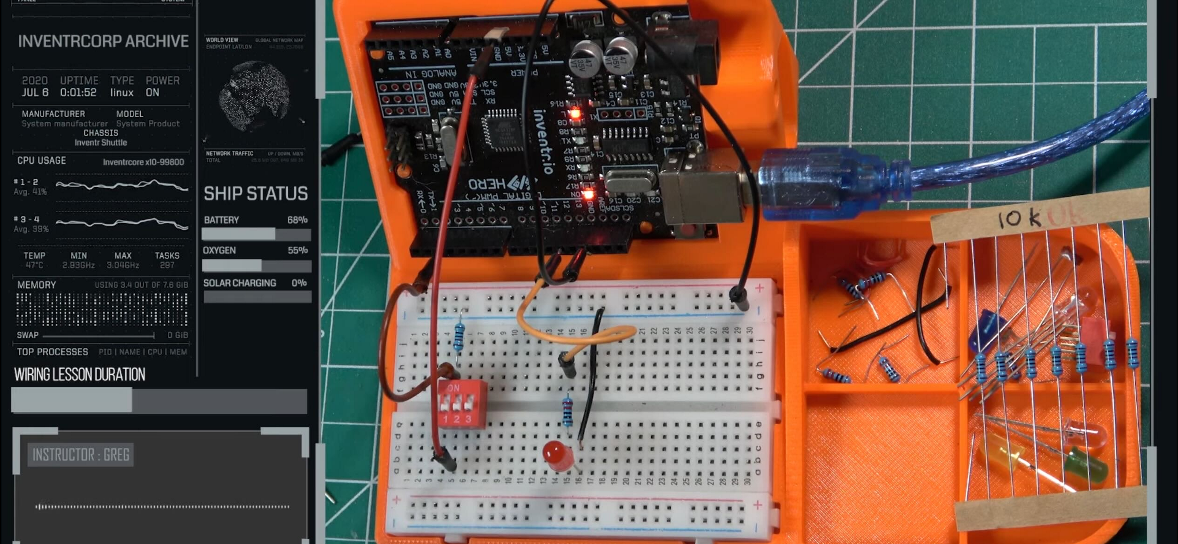

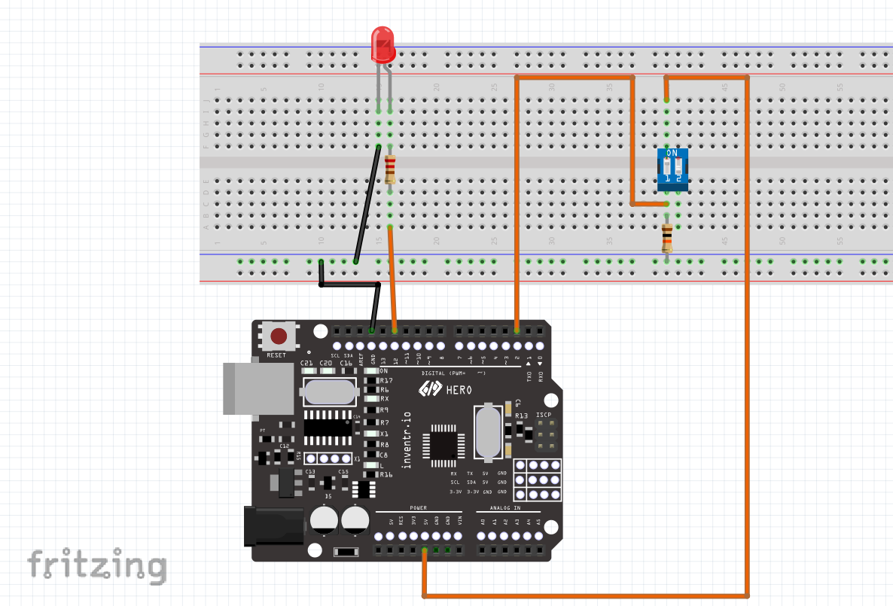

Advanced (This is actually Day 3)

Absolutely, Explorer! Now that you’ve got that LED blinking, let’s add some interactivity by introducing the DIP switch. This will give you control over when the LED blinks, and it’s a great step into working with inputs.

### Materials

* 1 DIP Switch (we’ll use one of the switches for now)
* 1 LED (reuse the one from your last setup)
* 1 Resistor (220 Ohm for the LED, and a 10k Ohm for the switch)
* Jumper wires
* HERO board
* Breadboard

### Step-by-Step Instructions

1. Set Up the DIP Switch Circuit:
   * Place the DIP switch on the breadboard.
   * Connect one side of the DIP switch to pin 2 on the HERO (or any digital input pin).
   * Add a 10k Ohm resistor between the DIP switch and GND on the HERO board. This is called a pull-down resistor, and it will keep the switch from floating (giving random signals) when it’s off.
2. LED Circuit:
   * Keep your LED setup from before. Ensure one leg is connected to the 220 Ohm resistor, and the other leg is connected to GND.
3. Connect Everything to HERO:
   * Connect the other side of the DIP switch to 5V on the HERO.
   * Run a jumper wire from the other side of the 220 Ohm resistor connected to the LED to pin 9 on the HERO.

Alright, Explorer! Let’s simplify the DIP switch connection step-by-step to make sure we’re on the same page. Here’s the complete setup:

1. DIP Switch Positioning:
   * Place the DIP switch on the breadboard with one set of pins aligned in one row, and the other set in another row.
2. Connection to HERO Board:
   * Choose one switch on the DIP switch. Let’s use that single switch to control the LED.
   * One side of the chosen DIP switch should connect directly to pin 2 on the HERO board.
3. Adding the Pull-Down Resistor:
   * Connect a 10k Ohm resistor between pin 2 (where you connected the DIP switch) and GND on the HERO board. This resistor “pulls down” the signal to 0 (or LOW) when the switch is off, preventing noise.
4. Powering the DIP Switch:
   * Connect the other side of the DIP switch (the side opposite to the connection with pin 2) to the 5V pin on the HERO. This provides power to the switch.

### Check the Circuit

Once everything is connected:

* When the DIP switch is off, pin 2 should read as LOW.
* When the DIP switch is on, pin 2 should read as HIGH and turn on the LED based on the code.

1. Code for DIP Switch Control:
   * Upload this code to control the LED based on the switch position:

Code

const int ledPin = 9; // LED connected to digital pin 9

const int switchPin = 2; // DIP switch connected to digital pin 2

int switchState = 0; // Variable for reading the switch status

void setup() {

pinMode(ledPin, OUTPUT); // Set the LED pin as output

pinMode(switchPin, INPUT); // Set the switch pin as input

}

void loop() {

switchState = digitalRead(switchPin); // Read the state of the switch

if (switchState == HIGH) {

digitalWrite(ledPin, HIGH); // Turn LED on if switch is on

} else {

digitalWrite(ledPin, LOW); // Turn LED off if switch is off

}

}

Upload and Test:

* + When you flip the DIP switch, the LED should turn on or off depending on the switch’s position.

Give it a try, Explorer! This setup adds a new level of control and prepares you for using more complex inputs later. Let me know how it goes, and if you’re ready, we can make things even more interesting!

